**Student Troubleshooting Guide (as of 9/7/2020)**

**Common Schoology Error Messages Received & How to Fix Them**

* **Google Drive/ One Drive files in an assignment are not visible.**

Look for where the screen says, “Can’t see your document?” and then follow the directions to Click.

* **You cannot log into Schoology.**

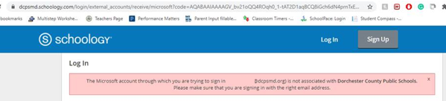 or 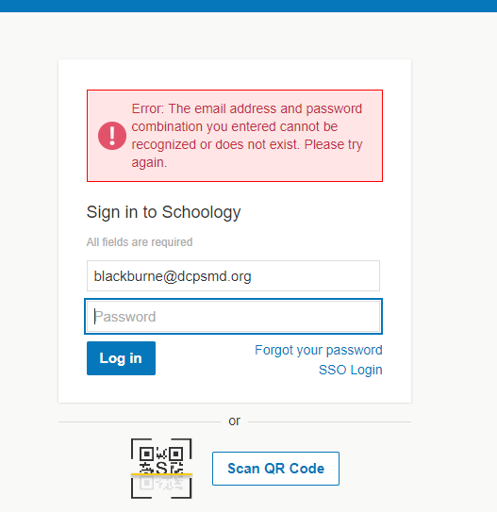

How to Resolve the Issue

1. Make sure you are logging in at <https://dcpsmd.schoology.com>
2. Remember to use your full DCPS email address and your DCPS password as your login credentials.
3. Tell your teacher and ask them to contact IT.

**Schoology Reminders**

* Schoology works best with Chrome as your browser.

**Common Google Meet Error Messages Received & How to Fix Them**

* **You cannot access Google Meet.**

How to Fix It

* + Make sure your computer is online and you are going to <https://meet.google.com>
  + Use the access information provided by your teacher.
  + If you are still unable to access the meeting, please let your teacher know.
* **Camera/microphone is disabled.**

How to Fix It

* + Students without a DCPS laptop may not have access to a camera or microphone.
  + If they have a DCPS device, Meet needs permission to use your camera and microphone in Chrome. You will be asked to allow access the first time you join a Meet video call.
  + You can change the setting to allow Meet to use your camera and microphone, click on the camera icon  in the address bar and select the **Always allow** option.
* **You are prompted to download Chrome.**

Chrome is not the default browser.

How to Fix It

1. On the computer, open Chrome.
2. In the top right, click More.
3. Click Settings.
4. In the "Default browser" section, click Make default. If you do not see the button, Google Chrome is already your default browser.

* **I cannot open Meet on my mobile device.**

You may have missed an app update.

How to Fix It

Update your app to the latest version.

**Google Meet Reminders**

* Google Meet works best with Chrome as your browser.